2017 Council of Federation

Literacy Awards

Literacy skills are crucial to daily living, employment, citizenship, personal advancement and quality of life. In order to bring recognition to literacy achievements, the premiers of Canada created the Council of the Federation Literacy Awards in 2005. The 2017 Northwest Territories Council of the Federation Literacy Award will honour the achievements of an adult learner who has overcome challenges and demonstrated outstanding progress in the pursuit of literacy skills in any of the eleven NWT Official Languages.

Who is eligible?

- NWT adult learners who have excelled in literacy achievement, improved personal literacy levels and helped others to improve their literacy levels. The learner must have been enrolled in classes within the past 18 months.

How many winners will there be?

- One award winner

What does the Council of the Federation Literacy Award winner receive?

- The award winner will receive a Council of the Federation medallion, a cheque for $300.00 and a certificate from the Premier of the Northwest Territories

What is the nomination format?

- Fill out the nomination form. At least two letters of support are required.

- Additional supporting material, such as photographs, audio-visuals, and samples of the nominee’s work will be accepted.

- Send to: Kathryn Walker
Wellness and Literacy Coordinator
Education, Culture and Employment
P.O. Box 1320
Yellowknife, NT X1A 2L9
Fax: (867) 873-0109
Phone: (867) 767-9351 ext. 71180
Email: kathryn_walker@gov.nt.ca

When will the award be presented?

- The awards will be presented at a ceremony in Yellowknife in the fall of 2017.

When is the deadline for submitting nominations?

- The deadline for nominations has been extended to Friday, June 23, 2016.

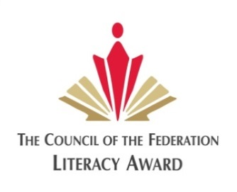
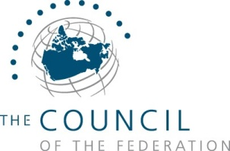
2017 Council of Federation Literacy Awards
Nomination Form

Name of nominee:
Nomination category:
Address:
Phone number:
Fax number:
Email:

Please answer the following questions:

- Why do you believe the nominee should be recognized for efforts to improve personal literacy levels?

- Write down some of the nominee’s literacy achievements, giving examples of how they have overcome educational and literacy challenges.

- How has the nominee helped others to improve their personal literacy levels?

- Please describe the nominee’s involvement with community literacy. In what way has the nominee been a role model to others?

Name of nominator:
Address:
Phone number:
Fax number:
Email:

Additional Requirements:

_____ Attach two letters of support with the nomination form.

_____ Provide a list of support materials such as photographs, audio-visuals, publications and products which are being submitted with the nomination.

